|  |
| --- |
| Kenneth aquin  DCET 3-1 |

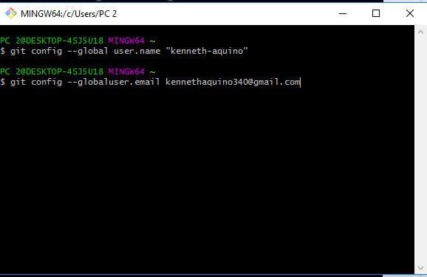

274975547_1067811990433334_4717204852671616005_n

